Half Adder

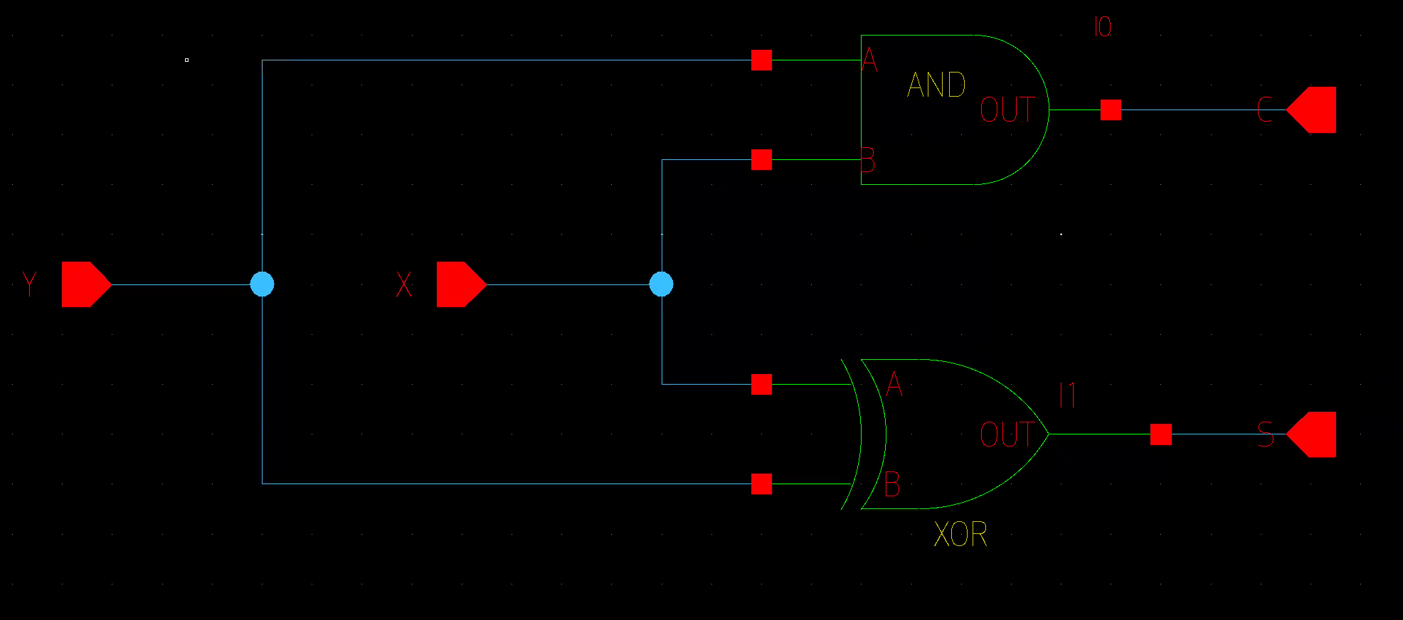

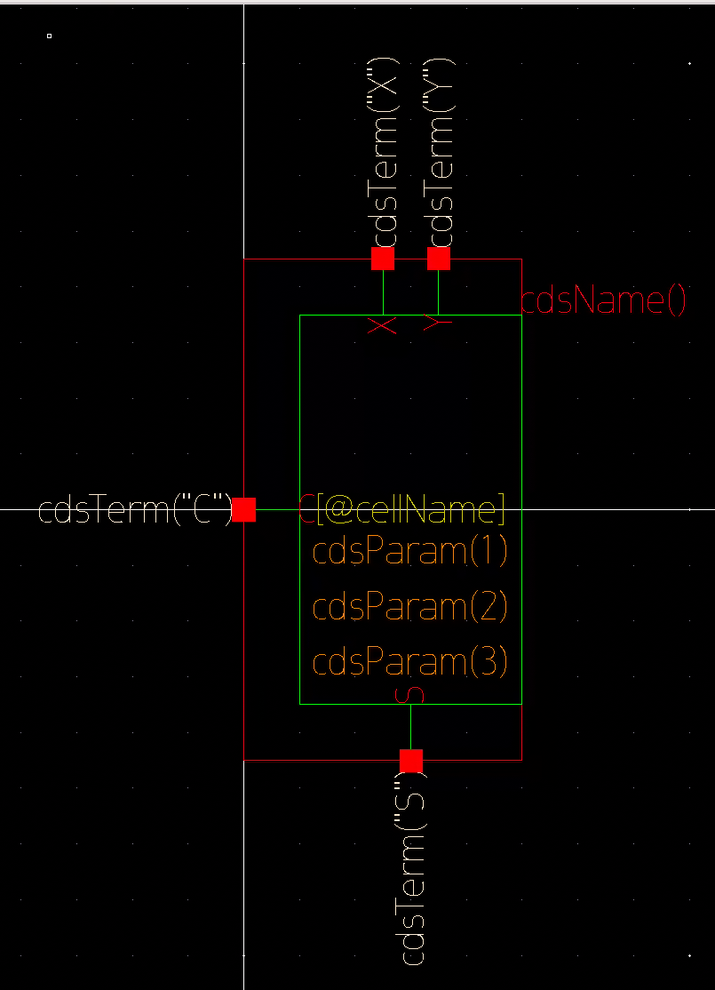

Full Adder

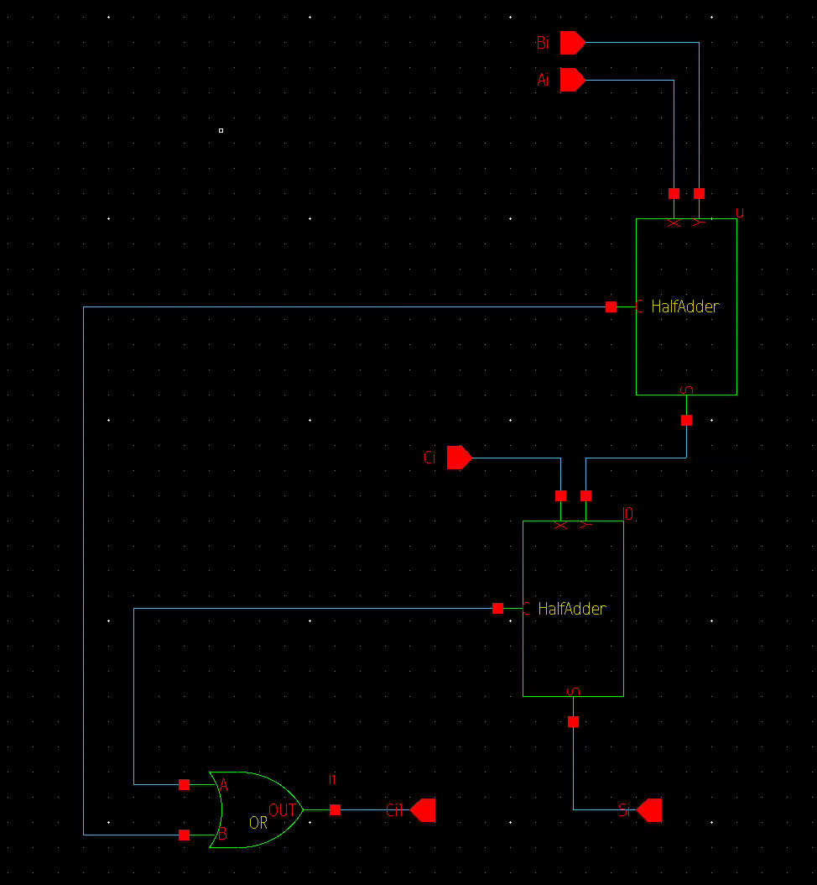

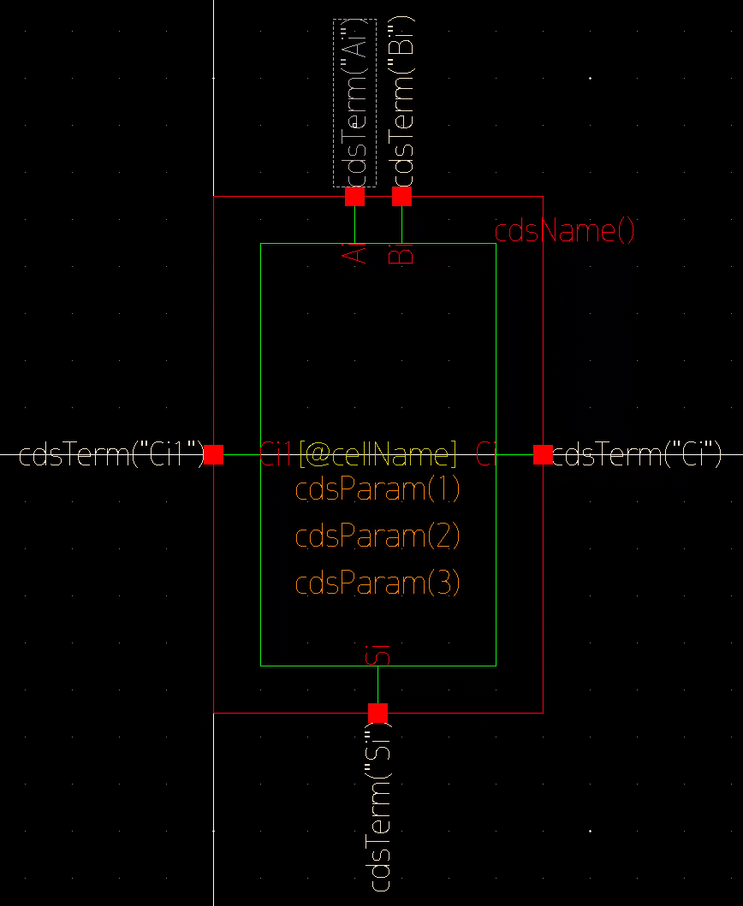

Four Bit Adder

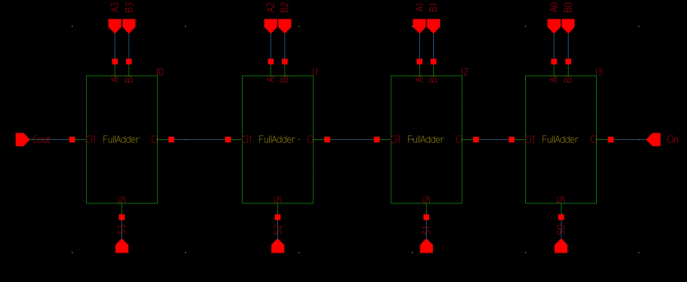

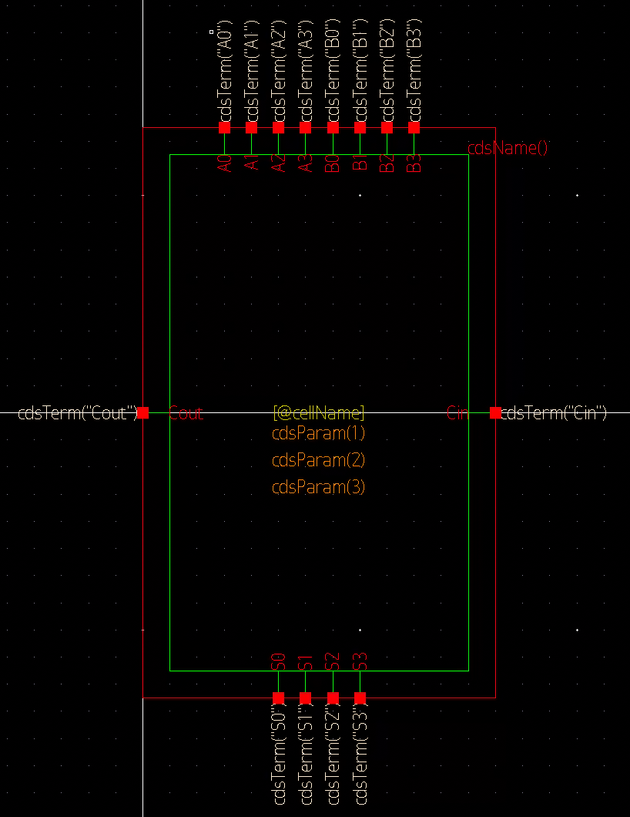

Testbench Schematic

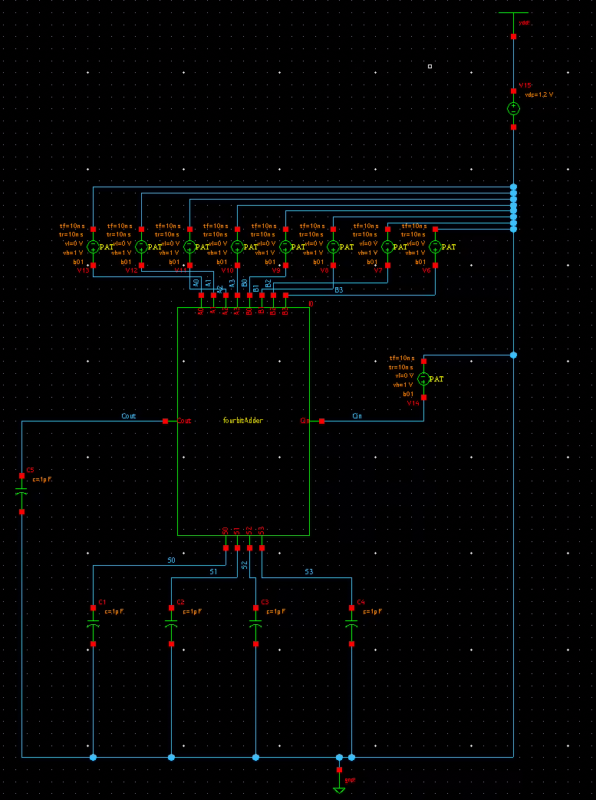

SAE

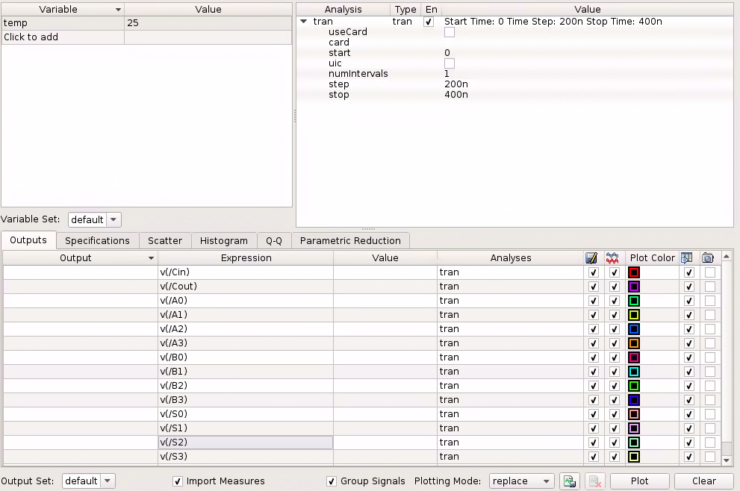

Question:

You would connect the Cout of the 4-bit ripple carry adder and connect it to the Cin of the next 4-bit ripple carry adder to make an 8-bit adder.

Conclusion:

You can make a full bit adder using half adders. You can also make ripple carry adders using full adders.